Tuesday, 13 October 2020

Dear Parent / Carer

Firstly, I would like to personally thank each and every one of you for working with us during this first half term. It was an absolute pleasure to read through your feedback from our recent parent survey, some of which can be found below:

“Very Happy so far with what I’ve seen, communication with parents is brilliant.”

“Thank you for making my child’s school experience a delightful one.”

“The teachers are passionate and motivated to ensure the children have the best learning experience.”

“This was the best choice I could have made for my child moving her to UTC, amazing support and communication from staff.”

“Has been a great decision for my child.”

“Nothing is too much trouble.”

From the responses collated:

99% agreed that “My child feels safe at this school”.

98% agreed that “My child is happy at this school”.

98% already said “I would recommend this school to another parent” with the other 2% saying it was too early to say just yet.

I have shared with our wider team your words of encouragement, praise and recognition of the work that they have all been doing. Thank you once again.

Amongst the feedback given there were some genuine questions and comments to which we would like to respond to.

It was asked if there would be opportunities to know more on how students were performing academically. Scheduled on our academic calendar are three Learning and Progress Days. Here you will have the opportunity to look at your child’s assessment results and attitude to learning scores; as well as highlight strengths and next steps with their tutors and teachers. More information on these will follow with the first one scheduled just before the Christmas Break.

In order to support further at home, it was also asked if an overview could be provided of topics that students were covering in their subjects. Full course overviews are on The Doncaster UTC website; however, we recognise that a more broken-down list of what is being covered when would be most helpful. We will therefore collate this for the next half term and send out to all parents. Longer term we will look at how this can be incorporated into potentially our website and subject pages.

During the two weeks of home learning it was asked about online lessons. This is something that we are very much looking into. At the start of the two weeks a technology survey was sent out which revealed that more than one quarter of our students did not have access to their own device at home. We therefore made the decision to provide lessons in a way that we felt were accessible by all. Since returning to the UTC all students have participated in a Microsoft TEAMs lesson and received information on E Safety. Training for staff and students will continue on this. Once our initial SIMs Pay issues have been resolved we will also be able to implement our device loan scheme to ensure all students can access technology.

We appreciate your feedback and therefore the survey will be revisited at the end of next half term. We anticipate that after further time with us you will be able to comment on other areas and we look forward to receiving this.

Should there be any further information you require please do not hesitate to contact me.
Yours sincerely

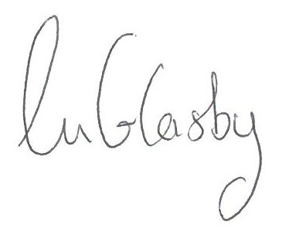

Ms Lindsey Glasby
Senior Vice Principal

